President Elect Trump
November 9, 2016
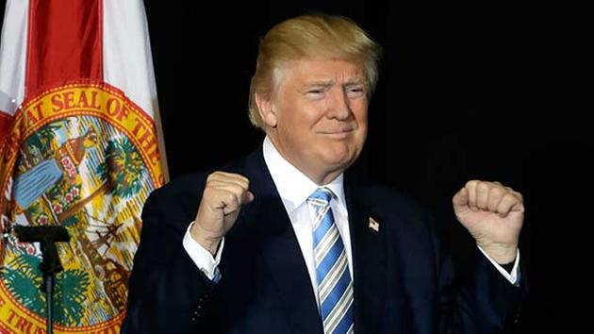
The Lord has done it again. Against the odds and the opposition, He's managed to put His man in office as President of the United States. And He began speaking to me tonight by saying,

"My Mercy for this country will be felt tonight. The prayers of My servants have been heard - for they have humbled themselves and sought Me. Shall I not grant them the respite they so desire?

"Yet there is cause for concern, do not imagine that any man will follow perfectly My will, but this man, I have anointed, for better and for worse.

"Yet the challenges he is facing in the coming months are beyond human comprehension. But I comprehend them and he has opened his mind to listen to My wisdom, though he rarely recognizes it is Me talking to him.

"Nonetheless, he is anointed, because his heart is right. No matter that he is blustery and proud, he is more shrewd than what appears on the surface. As long as that submits to My wisdom, it is a good kind of shrewd.

"He will be a world leader that everyone respects - whether they like him or not, they will respect him. He will set some major issues in America back on the right track.

"But Clare, this is the world and what can be expected? Nonetheless, he will do a good job with what is ahead of him.

"How can 60 years of corruption at the highest levels be righted overnight? Only by My coming can that happen.

"But for now, America has another chance to drop her compulsions with materialism and begin to take responsibility for the policies in this nation. People have been led around by a golden ring in their noses, enjoying the fat of the land. This in turn produced a blind generation, all taken up with material comforts and education, thoughtless about the true nature of those she elected.

"Nonetheless, I am with this man, and I will reorder things through him. This nation has made a wise choice and now I can work with it."

And I asked Him at that point, "But Lord, how will he escape assassination? That seems impossible to me."

The Lord replied, "With God…."

And I finished the sentence, “....Nothing is impossible.” Lord, how will this happen?

"Clare, I have given My angels watch over him, nothing escapes their notice. Your job is to lift him up over the altar every day, Mine is to protect him and his family. I have chosen him, I will not abandon him to the will of his enemies, as long as you continue to pray for him. There will be new hurtles, but together we will overcome them, one by one.

"Whatever your thoughts about this man, those who call yourselves by My Name, he is now your president and has authority over your country. Pray for him, he will do well. Grow lax, and he will be replaced with a dictator. Do not grow lax, strengthen him with your prayers and fast offerings when called for.

"This is a new day for America. Be faithful to pray, I will be faithful to guide and protect him and his family."

All glory and honor and praise to You, Lord Jesus! What a wonderful thing You've done for this country today. Thank You, Lord. Thank You so very much. For You indeed have done great things.

And thanks to all of you, Heartdwellers, who've really applied your hearts, your tears and your prayers to make this possible.

